OH&S Risk Assessment
Name of task/activity |  | Date of risk assessment:
Faculty/Department: |  | Review date:
Location of activity |  | Approved by:
Risk Assessment undertaken by |  | Date of approval:

Risk Assessment Rating
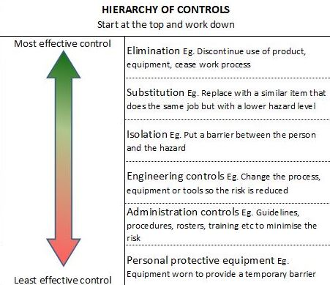
Use this table to determine risk rating
What is the worst possible CONSEQUENCE of the hazard?
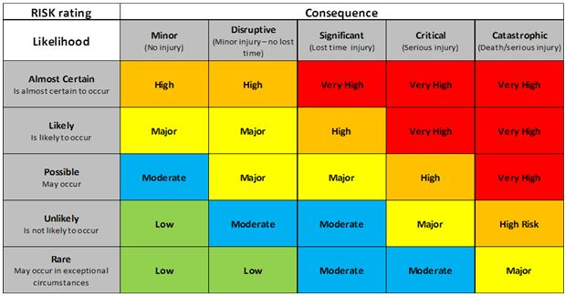
What is the LIKELIHOOD of this occurring?

Step of activity/event | Who might be harmed and how?  (what are the potential hazards and who will they effect) | Current risk rating  (without any controls) | Controls required  (what will you do to make the activity safe) | Residual risk rating  (after applying the controls) | How will the controls be implemented
 |  |  |  |  | Person/s responsible | Due date | When completed

Sign off and acceptance:
Your signature below indicates you have read and understood the above risk assessment and will adhere to the controls at all times. Should any unexpected situation arise that hasn’t been identified above, please seek assistance from your Swinburne Student Life contact immediately.
Name (print) | Signature | Date

